|  |  |  |  |  |  |
| --- | --- | --- | --- | --- | --- |
| Date | 22-Nov-22 | | | Tester Name | Mayuri Patel |
| Environment | Penfax - Test | | | Login used |  |
| Operating System | Select OS | Version: | Update: | | |
| Software Used | Select Software | Version: | Update: | | |
| Select Software | Version: | Update: | | |
| Release version | 22.4.1 | | | | |
| Title | Active designated member | | | | |
| Test Type | Regression | | | | |
| Test Scenario | Active designated member | | | | |
|  |  | | | | |
| Expected Results |  | | | | |
| Pass/Fail | Pass | | | JIRA# | N/A |

Describe your steps with screenshots:

Search a MEPP active Designated member

Open that member profile

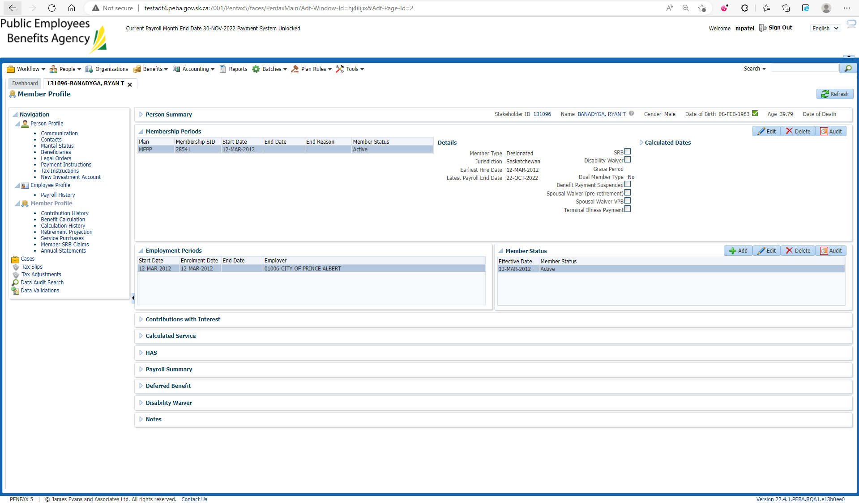

Go to Marital status under Person Profile

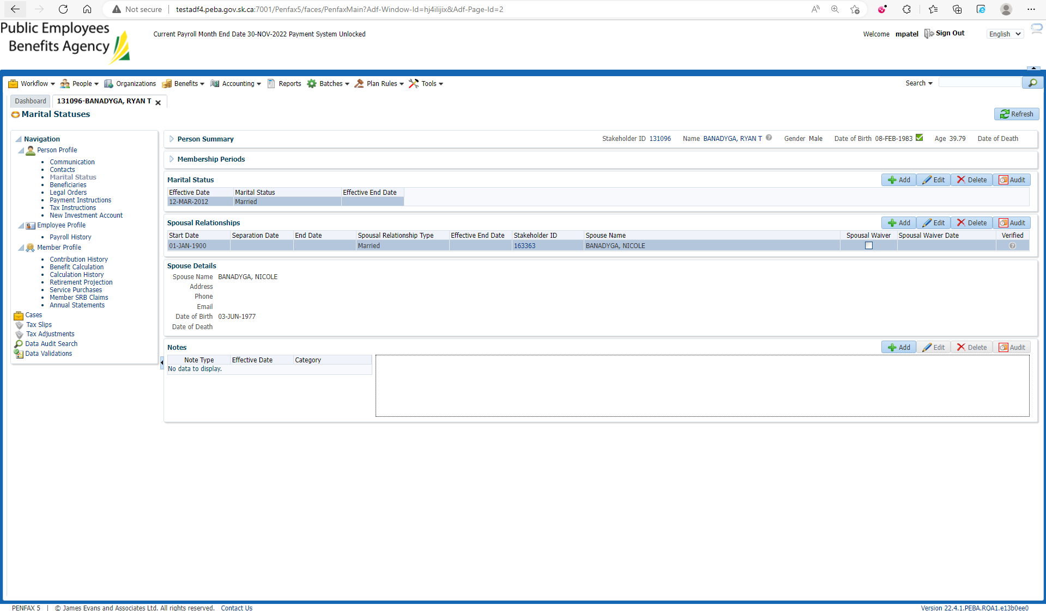

End the spousal relationships and marital status with effective End date

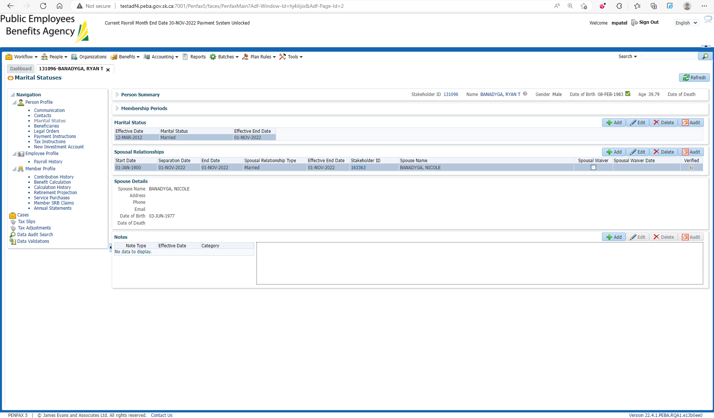

Go to Member SRB Claim

Add SRB Claim

Enter claim status to Estimate and Continue

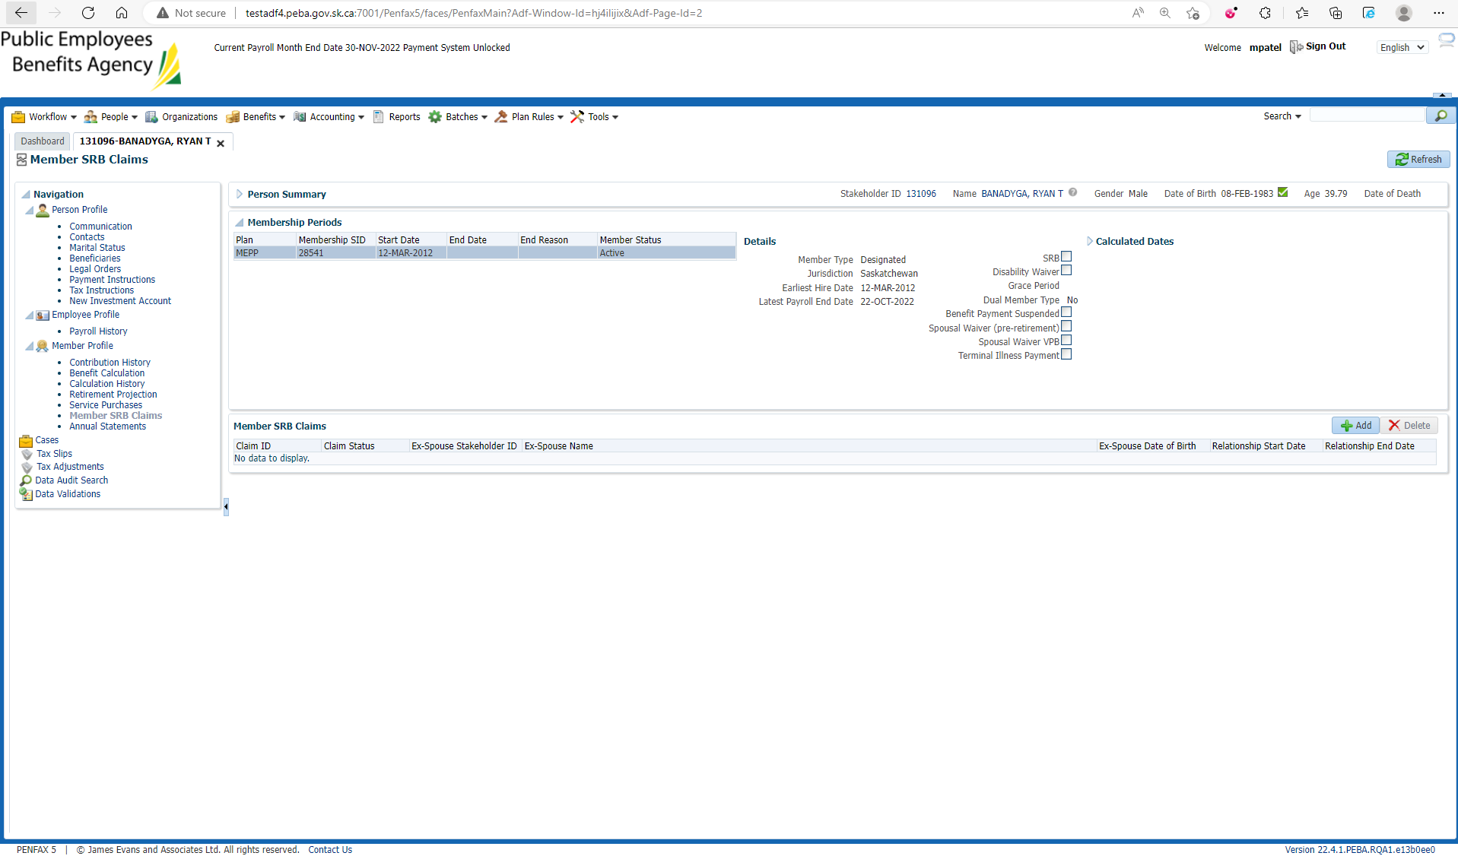

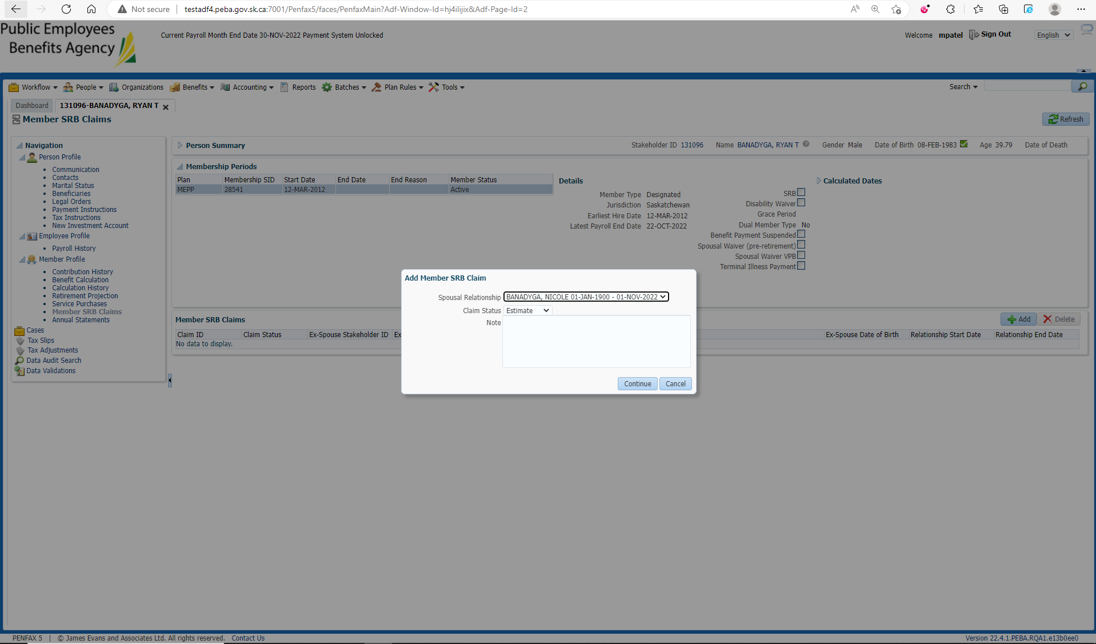

New member SRB Claim is added

Open that added SRB Claim

Edit claim status to in progress

Process the claim

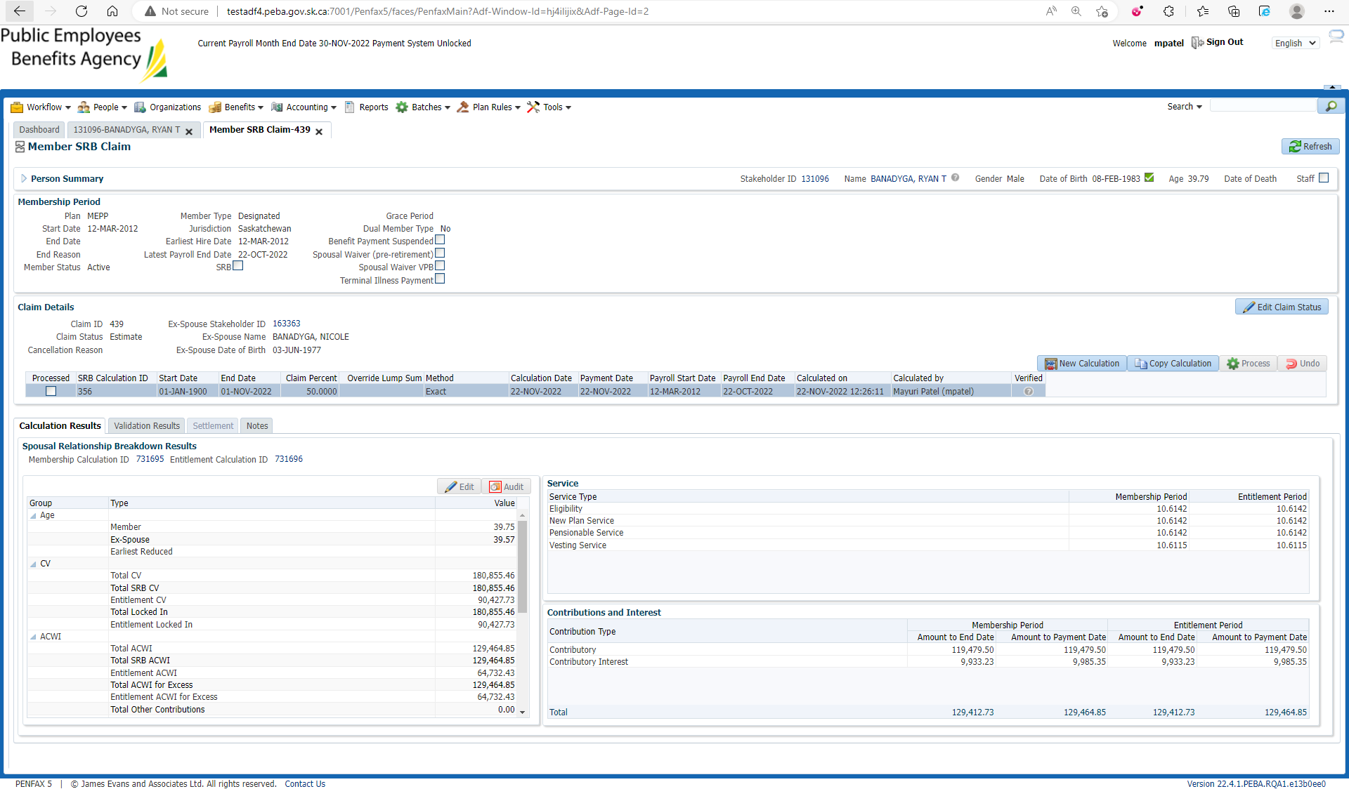

After processing Create Ex-Spouse Benefit button is enabled and click it

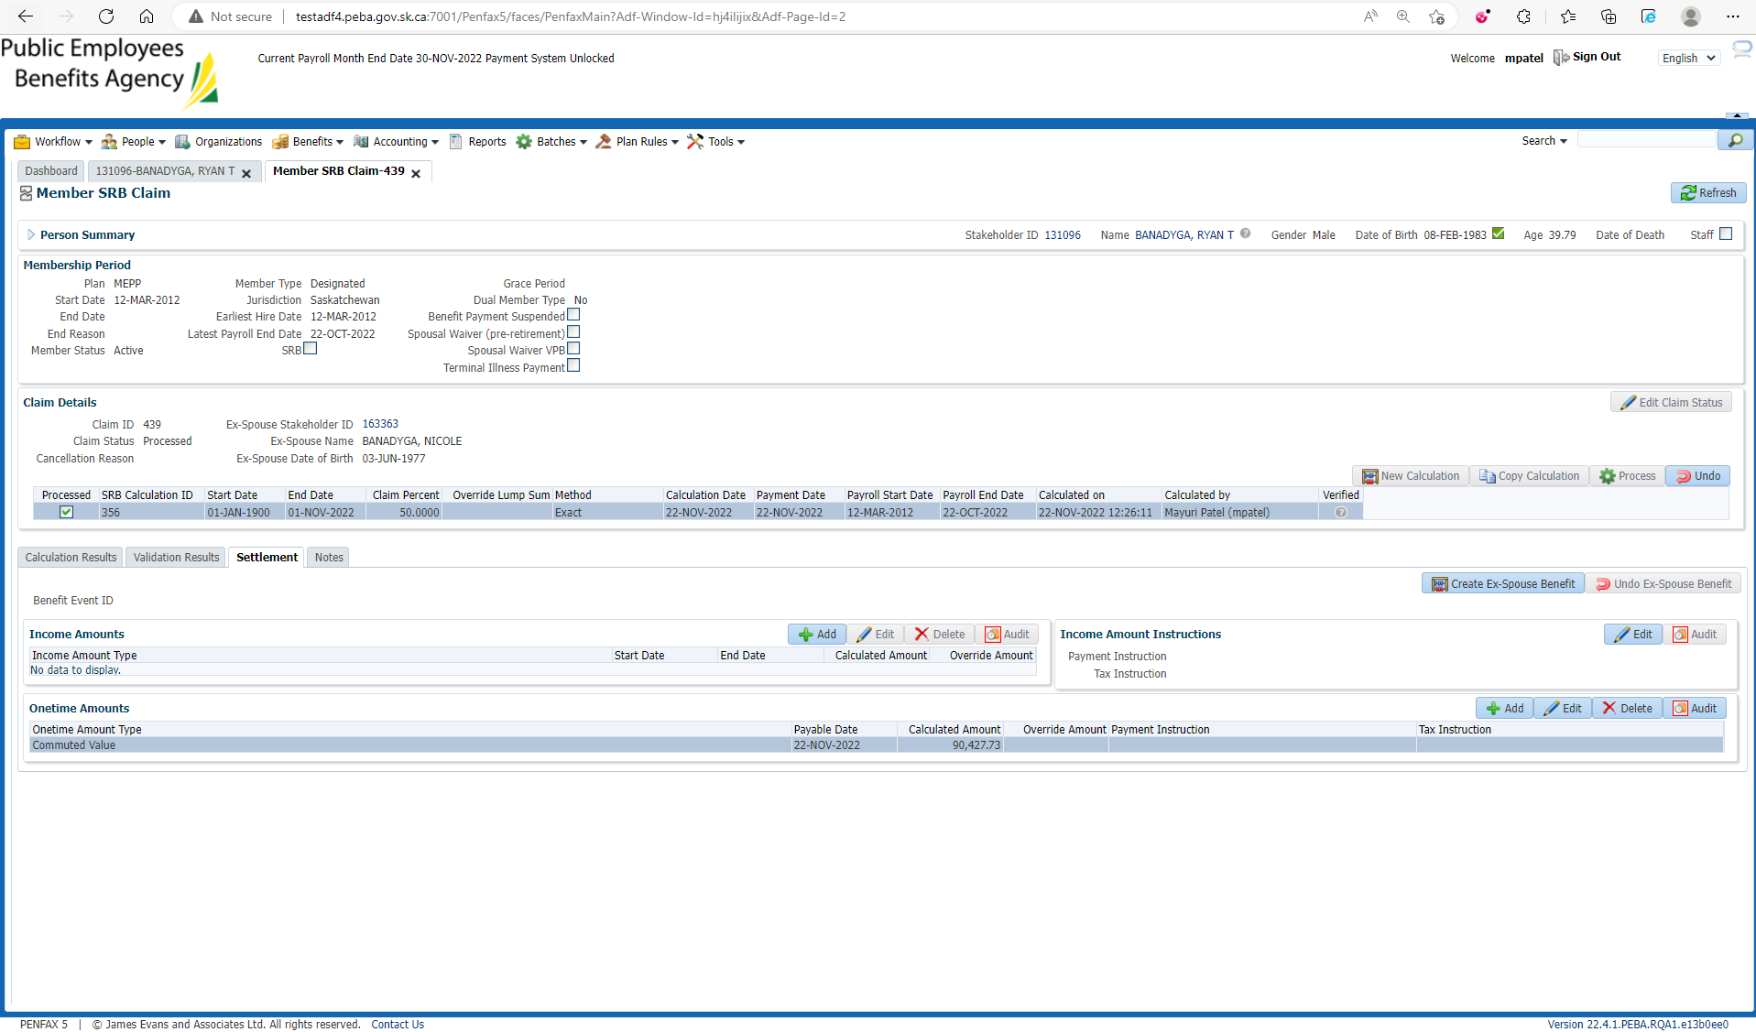

Benefit is created on Beneficiary Profile

So now Open Beneficiary Profile

Go to Benefit Recipient🡪Onetime Amount tab

Submit for Approval and Approve the SRB benefit

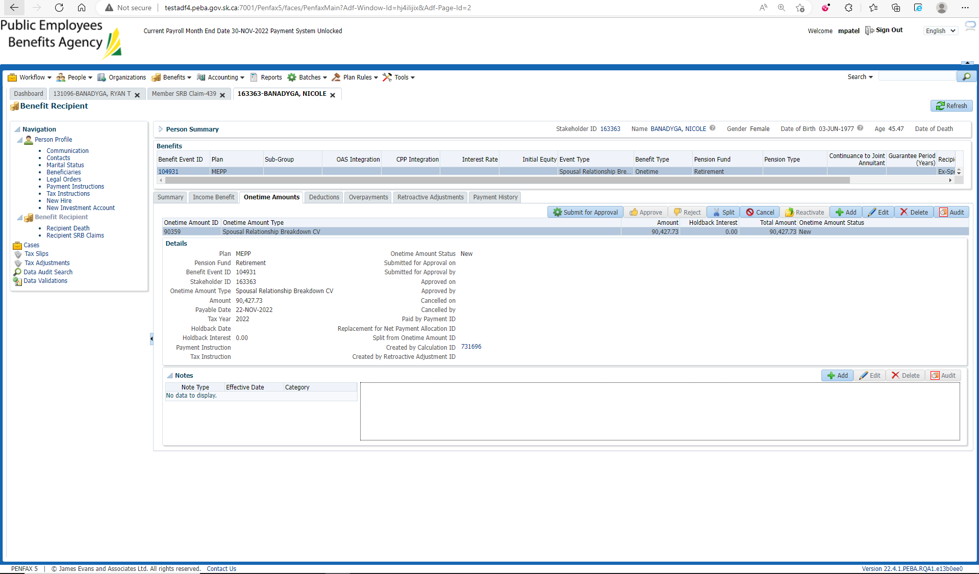

Under Summary tab Authorize the benefit

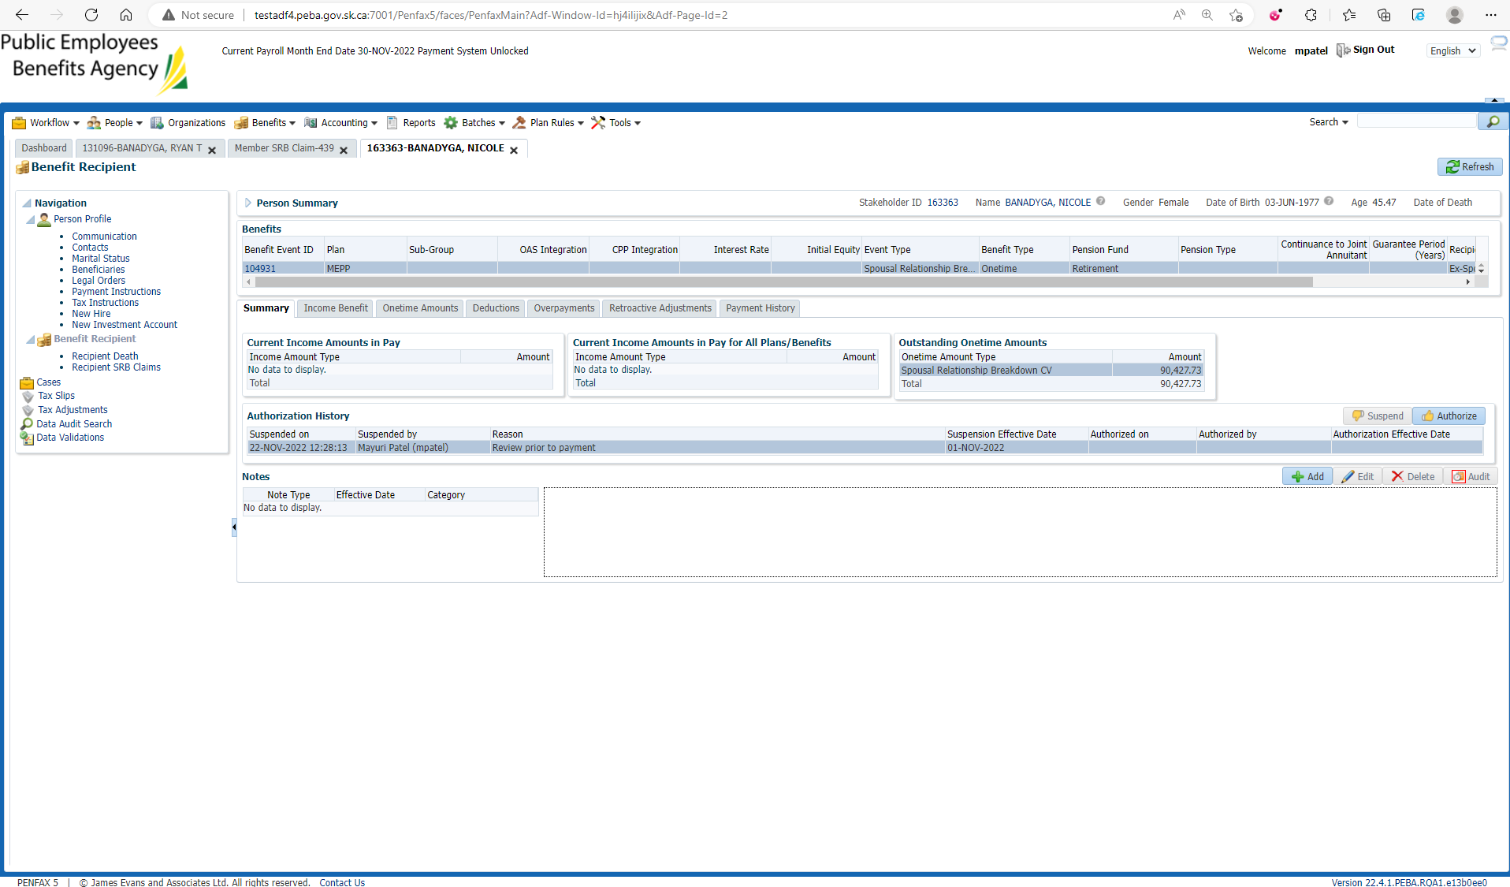

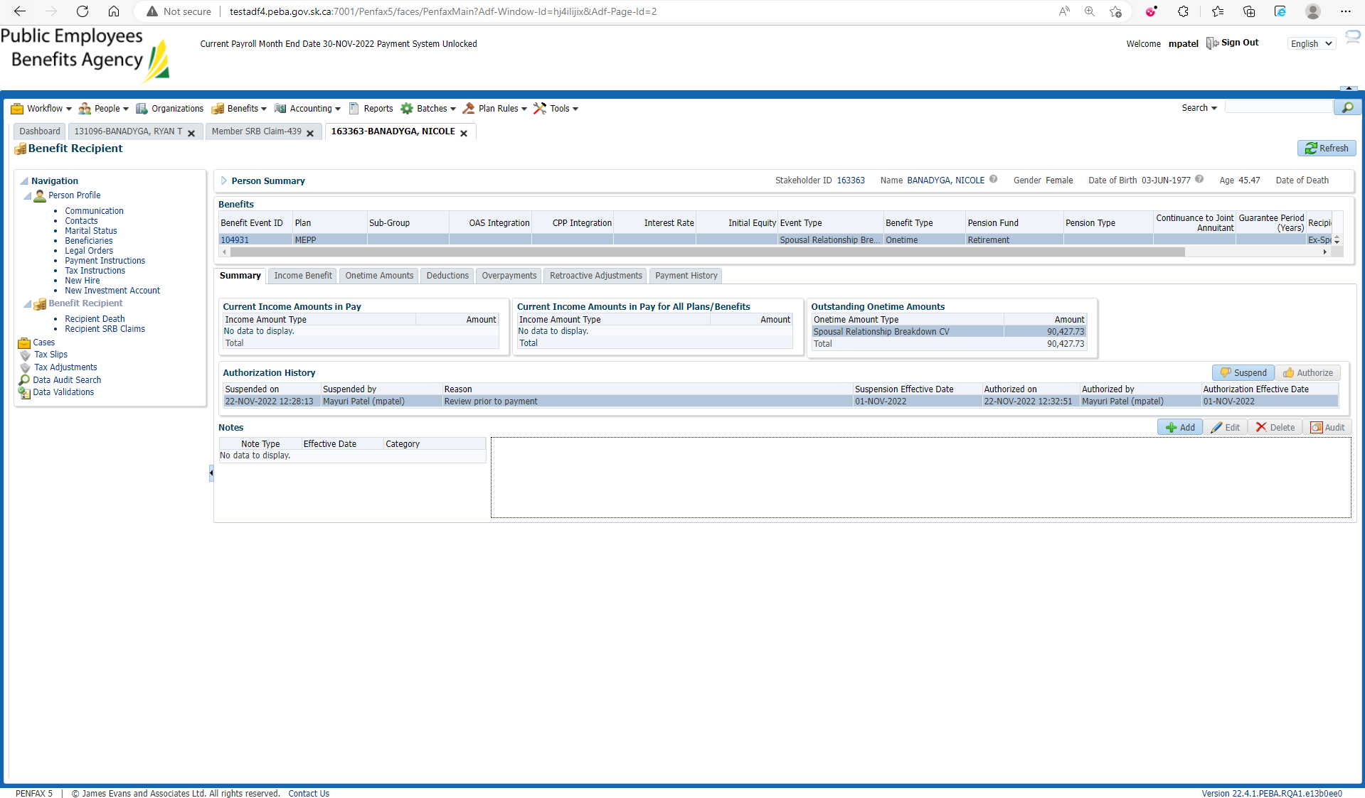

After payment Batch processing

Open Beneficiary Profile again

Benefit is now paid

